POWER ELECTRONICS
FINAL PROJECT TASK 3

By:
Robert Valois & Olasubomi Borishade

Department of Electrical Engineering
University of North Texas, Denton
Discovery Park

EENG 4580.001 - Power Electronics
Dr. King Man Siu
November 26th, 2024

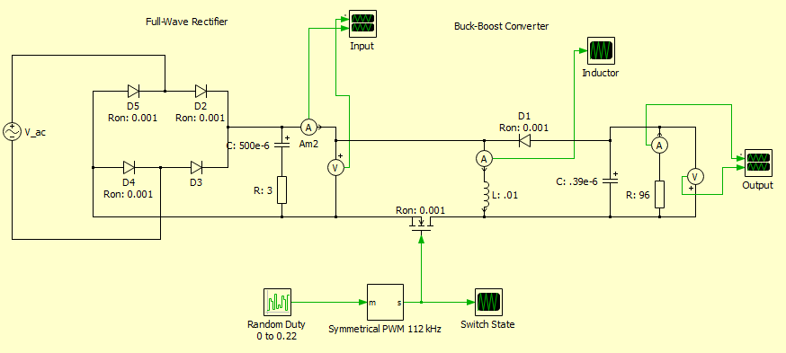

THERE ARE 2 CONTROL STAGES OF THIS PROJECT: THE RECTIFIER STAGE AND THE REVERSE BUCK-BOOST STAGE. THIS PROJECT IS SPLIT INTO THOSE SECTIONS.

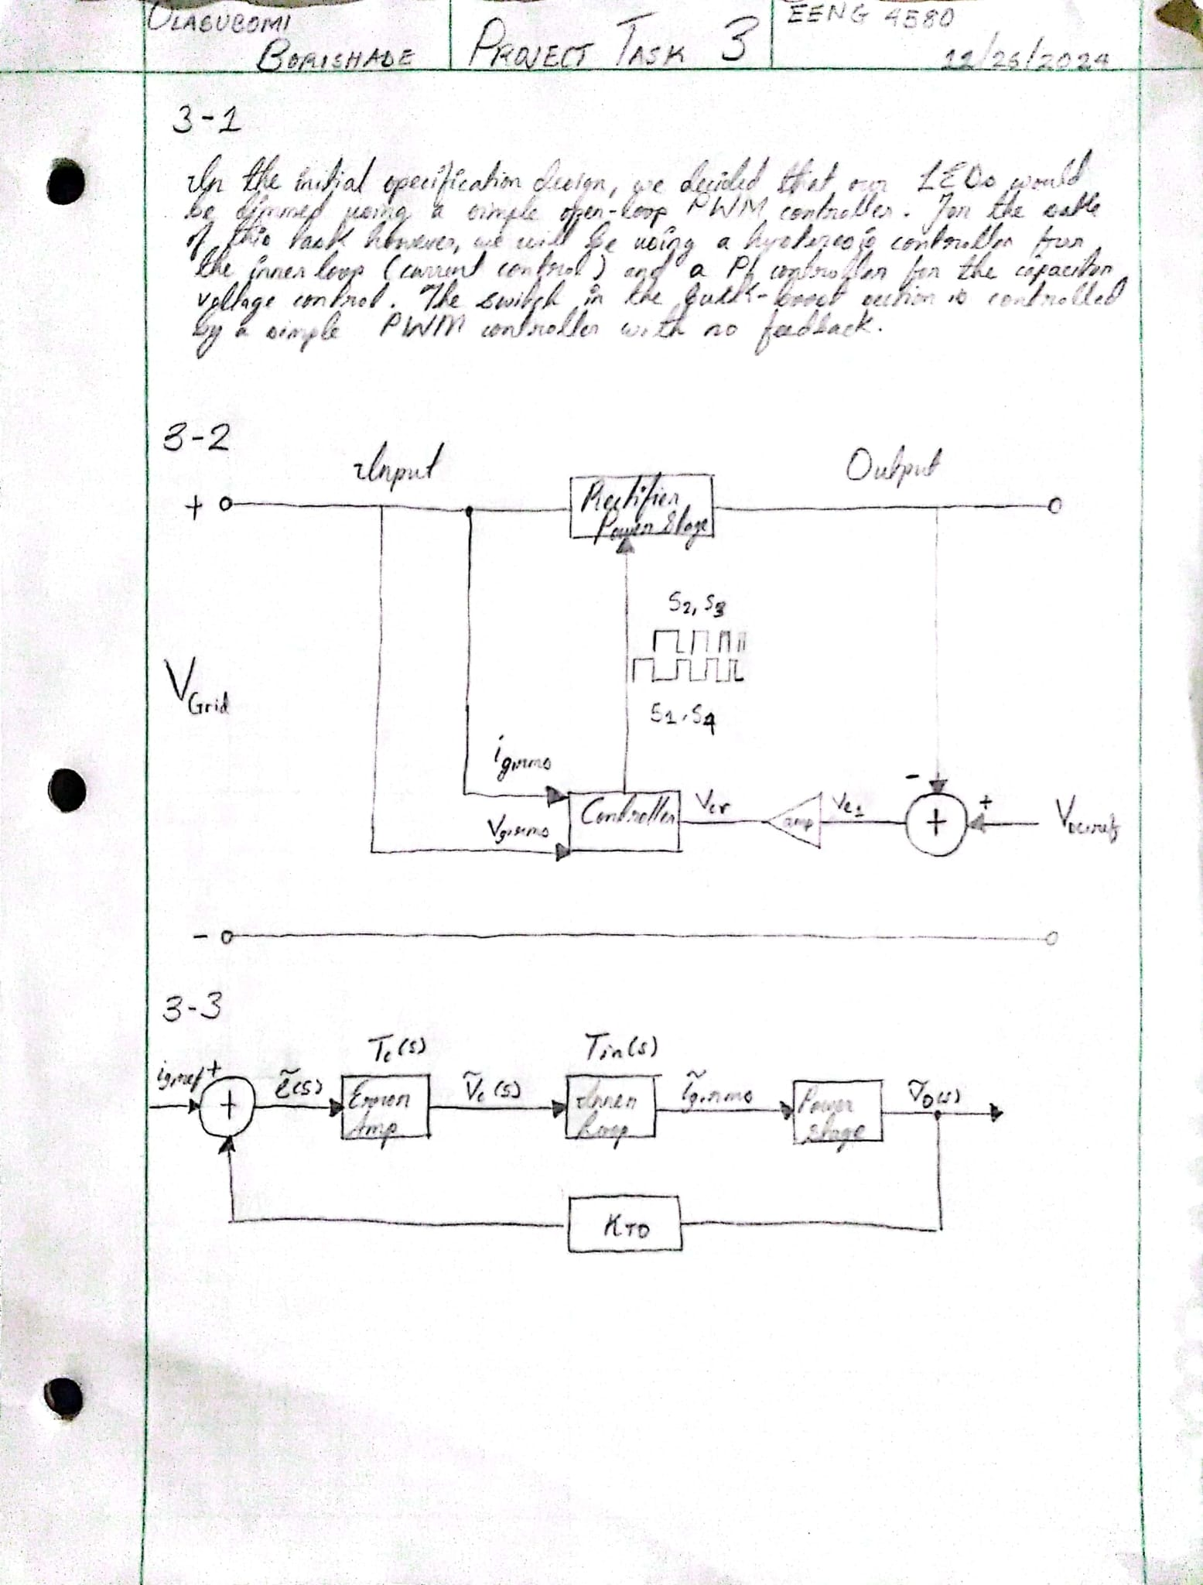

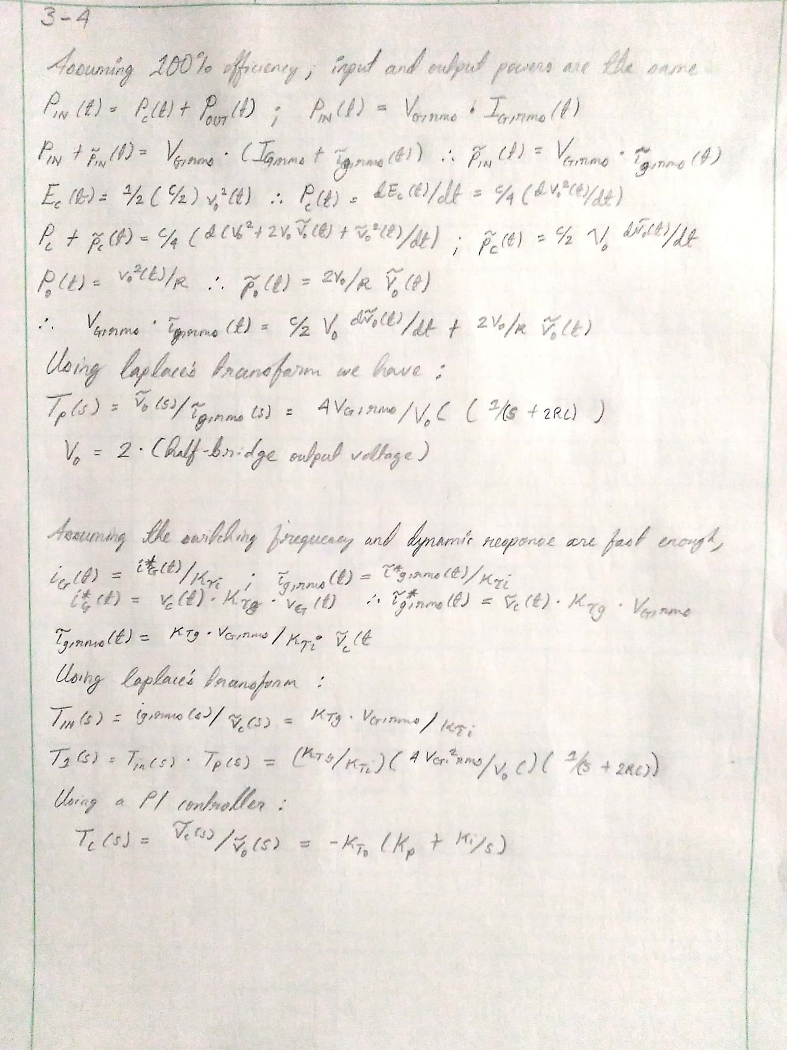

3-1
Identify the control target of your circuit:

The control target is the duty cycle.

3-2
Draw the control block diagram for your circuit:
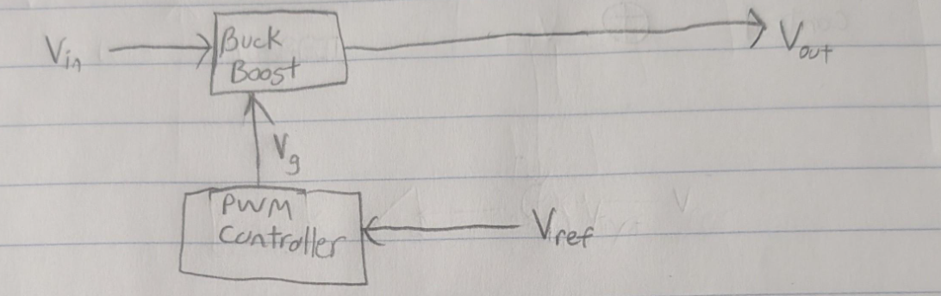

3-3
Create the small signal block diagram for your circuit:

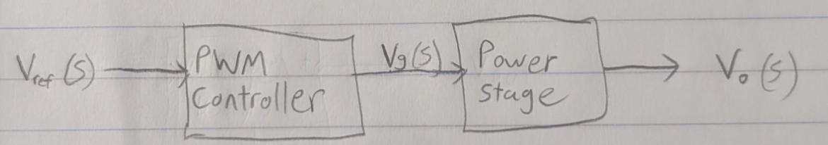

The voltage reference will come from the built-in reference in our comparator IC. We will sense the output voltage using a voltage divider to scale it down and compare it with the built-in reference. If the output voltage drifts from 48V, the comparator/error amplifier adjusts the error signal, modifying the duty cycle of the PWM to bring the output back to the desired value.

